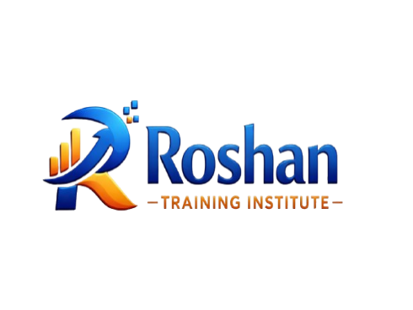
Every student gains AI and Data Analysis Skills for Competency in the Global Market.

SCHOOL PROFILE
ROSHAN TRAINING INSTITUTE.
Email. roshandatainstitute@gmail.com
Phone: 0702171149

Christopher

Principal

roshandatainstitute@gmail.com

Mr. Isaac
College and Career Counselor
s
CORE VALUES.

- Excellence.
- Integrity.
- Innovation.
- Learner-Centeredness.
- Practical Impact.
- Inclusivity.
- Continuous Learning.

CO-CURRICULAR

- Webinars and
- industry talks
Data challenges.
- hackathons.
- Freelancing and remote work clinics.
- Research and analytics clinics
workshops.

TARGET LEARNERS.
- University and college students.
- Form Four Levers.
- Recent graduates
- Working professionals
- Entrepreneurs and freelancers

MISSION
To empower learners with practical data analysis and AI skills through quality training, mentorship, and real-world applications that enhance employability, productivity, and innovation
VISION
To be a leading data training institute that produces competent, ethical, and innovative data professionals who drive impact both locally and globally.

THE INSTITUTE AND THE COMMUNITY

Roshan Training Institute (RDTI) was founded in 2023 by a group of data professionals and educators who recognized the growing global demand for practical, industry-ready data skills and need to understand AI and its application in real-world. The founders envisioned an institute that would bridge the gap between theoretical knowledge and real-world application, especially for learners and professionals in emerging economies. As demand for AI and advanced data skills grew, RDTI expanded its curriculum to include specialized training in artificial intelligence, data analytics, statistical software, Python programming, and data visualization. The institute also adopted a competency-based, hands-on learning model that emphasized using real datasets, project-based assessments, and mentorship—a distinguishing feature that set RDTI apart from traditional classroom-based training.

THE ACADEMIC PROGRAM
Designed to motivate and challenge all learners, the academic program at Roshan Data Training Institute is driven by competency-based learning and the highest possible professional standards. Training programs emphasize hands-on learning, real-world application, and ethical use of data.
Learners engage with real datasets, applied case studies, and project-based assignments that reflect workplace and industry realities. Continuous assessment ensures learners demonstrate practical proficiency in data tools, analytical thinking, and problem-solving. Programs are delivered through in-person classes, virtual learning, webinars, and intensive boot camps, providing flexible pathways for diverse learner needs.

HIGHLIGHTS OF THE ACADEMIC PROGRAM
• Training in Artificial Intelligence, Data Analysis, and Digital Analytics
• Advanced Microsoft Excel for data analysis and reporting
• SPSS and statistical analysis for research and evaluation
• Python for data analysis and automation
• Microsoft Power BI and data visualization
• Data collection tools including Kobo Toolbox, ODK, and Google Forms
• Research data management and analysis
• Remote work and freelancing preparation in data analytics
• Project-based learning using real-world datasets
• Capstone projects demonstrating applied competencies
• Mentorship, career guidance, and professional coaching

TEACHING AND LEARNING APPROACH

• Practical exercises and live demonstrations
• Applied case studies and simulations
• Individual and group-based projects
• Continuous learner progress tracking
• Mentorship and career guidance

Intake -Ongoing
TEST SCORES

January 2026
GOVERNANCE AND MANAGEMENT
Roshan Data Training Institute is managed by a professional leadership team with expertise in data analytics, training, research, and project implementation. The institute upholds strong governance structures, regulatory compliance, transparency, and ethical management practices.

• Academic institutions
• Non-governmental organizations (NGOs)
• Community-based organizations (CBOs)
• Corporate and private sector partners

PARTNERSHIPS AND COLLABORATION

.

Courses | Courses
SPSS | AI
STATA | Advanced Excel
SAGE | Power BI
KOBO/ODK | Graphic Design

